Assignment-3

Dashboard1
SuperMarket_SalesDashboard
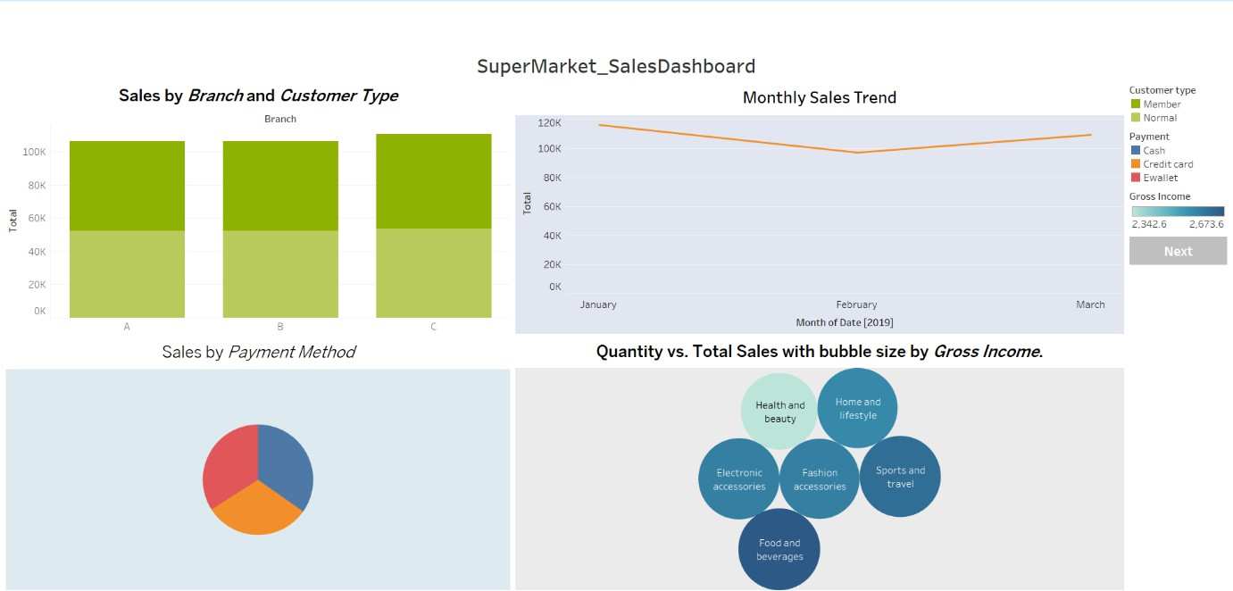

Dashbord2
Super Market_ProductSales Dashboard2
